Bucharest, 15th July 2016

Coface strengthens its risk function with the appointment of Thierry Croiset as Group Risk Director

Thierry Croiset, 56, will join credit insurer Coface as Group Risk Director as of 11 July 2016, reporting directly to Carine Pichon, Chief Finance & Risk Officer.

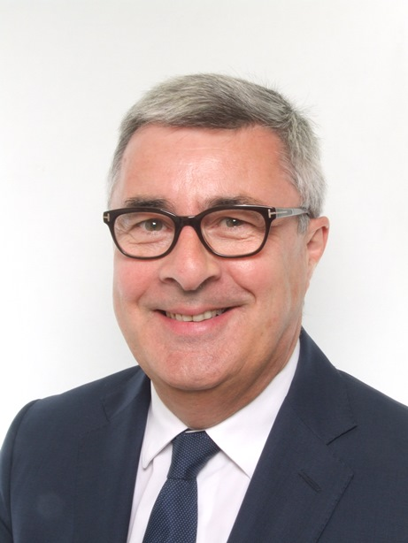
Thierry has more than 20 years of experience in the risk function in all facets of commercial and retail banking, SME and corporate lending and leasing, gained in GE Capital and banking groups Banque Populaire and CIC. His depth of expertise will be key in enabling Coface to strengthen its financial and non-financial risk management framework. Thierry also brings in-depth experience in managing large regulatory projects in different countries, notably in the framework of Basel regulations.

A finance graduate of the Reims business school (Sup de Co) in France, Thierry began his career at Ernst & Young as a Senior Auditor in 1985. He joins Coface from GE Capital, where over the last year he led projects to ensure compliance with Basel and Fed regulations, based in London. Prior to that, he was Chief Risk Officer for GE Capital in Japan between 2011-2015, and for GE Money Bank in France from 2006-2011. Thierry was Chief Risk Officer for the Banque Populaire group between 2000-2006, and previously held a number of senior credit risk and operating roles in Europe and Asia in the CIC banking group (1988-2000).

MEDIA CONTACT:
Emilia MUSCALU - T. +40/21/231 60 20 - emilia.muscalu@coface.com

FINANCIAL CALENDAR 2016 COFACE FRANCE
July 27th 2016: publication of H1-2016 results
September 22nd 2016: Investors’ Day
November 3rd 2016: publication of 9M-2016 results

FINANCIAL INFORMATION
This press release, as well as Coface SA’s integral regulatory information, can be found on the Group’s website: http://www.coface.com/Investors

About Coface

The Coface Group, a worldwide leader in credit insurance, offers companies around the globe solutions to protect them against the risk of financial default of their clients, both on the domestic market and for export. In 2015, the Group, supported by its 4,500 staff, posted a consolidated turnover of €1.490 billion. Present directly or indirectly in 100 countries, it secures transactions of 40,000 companies in more than 200 countries. Each quarter, Coface publishes its assessments of country risk for 160 countries, based on its unique knowledge of companies’ payment behaviour and on the expertise of its 660 underwriters and credit analysts located close to clients and their debtors.
In France, Coface manages export public guarantees on behalf of the French State.
www.coface.com
Coface SA. is listed on Euronext Paris – Compartment A
ISIN: FR0010667147 / Ticker: COFA

