Bucharest, 20th May 2015

Record decrease in the number of insolvencies in Q1, but at what cost?

Coface’s survey carried out based on the data provided by the National Trade Register Office shows that 2,740 new insolvencies were opened in the first quarter of 2015, down by approximately 58% compared to the same period of the previous year when 6,512 insolvencies were registered. However, in relation to 1,000 active companies, the rate of insolvencies is four times higher than the average registered at the regional level, Romania being in the first place from this point of view.

The record number of decreased insolvencies in the first quarter of 2015 is due to the decrease of insolvent companies with turnover below 100 K EUR. At the same time, the contraction is also due to a significant base effect (compared to a historical record registered in the previous year). Moreover, the number of insolvencies opened in the first three months of the current year among the companies with turnover exceeding 1 MEUR is 170, up by approximately 13% compared to the same period of the previous year. Thus, the social shock - the number of jobs which might be lost - is higher by 24%.

Sectorial and territorial distribution of insolvent companies

In terms of sectorial distribution, the manufacturing of textiles, sanitation and waste removal, construction, HORECA and food industry are the top 5 sectors with the highest number of insolvencies related to 1,000 active companies.

The territorial distribution of insolvency cases in the first quarter of 2015 suffered important changes compared to the existing situation in the same period of the previous year. Thus, if the number of newly opened insolvencies registered similar contractions compared to the previous year for all regions, the Southern and South-Western area stands out by a major decrease (-70%).

Evolution in time of insolvent companies

For a deeper analysis of the causes which determined the insolvency of companies in the first quarter of the current year, Coface has made an analysis of the financial statements of these companies for the period 2008 - 2013. Thus, it can be noticed that:
- One of the main causes which accelerated the risk of insolvency was the gradual unbalance of the balance sheet structure. Thus, the respective companies have attracted additional financial resources (the indebtedness degree reached almost 95% in 2013) which were mainly focused on long-term investments;
- These long-term investments did not generate additional revenues or a productivity increase through improvement of the operational margin. On the contrary, the average revenues have decreased and the dynamics were not coupled to an appropriate adjustment of expenses;
- The companies which became insolvent in the first quarter of 2015 registered a double average duration for the collection of receivables, gradually increasing from 82 days (2008) to 155 days (2013). This has determined the increasingly slow payment of the invoices to the suppliers, the average payment duration becoming almost triple in the same period, from 85 days (2008) to 239 days (2013).

Aspects observed among insolvent companies do not remain isolated from the general situation of the Romanian economy, but fit into the overall context of a funding structure of private companies. Thus, the claims reported in the balance sheet by private companies almost doubled in the last 8 years, rising from 167 B RON (2007) to over 310 B RON (2014). In this context, the level of cumulative trade receivables recorded nationwide for 2014 exceeds nearly three times the balance of bank loans given to non-financial companies.

In case of the financing method of companies, the Coface analysts estimate that the request for credits registered in 2014 is approximately 10 times lower than in 2008. The financing restrictions which persisted in the period 2009-2012 and which had a stronger character for the SMEs made the large and very large companies play an increasingly significant role of “commercial banks” for their clients, preferring to accept extended payment collection deadlines. In the context of these structural changes in the economy, the effect of contagion and propagation of negative shocks is much faster at present, the more so as the phenomenon of insolvency of an increasing number of large and very large companies accelerated in the first quarter of the current year.

„The decrease of insolvencies is rather explained both on a base effect and a comparison with a volume record of newly opened insolvencies in the last year’s same period. Thus, 98 % of the decrease in insolvencies was found among small companies, while the number of insolvent companies that registered a turnover of more than 1 MEUR is up to 13 %. Moreover, the ratio between the number of companies that stopped their activity (of all forms ) relative to the number of new companies registered (SRL) has increased nearly five times in the analyzed period, from 0.48, the level recorded in 2008, to almost 2.32 in 2014. Therefore, the effect of private economic regeneration system remains heavy, given that Romania still suffers as far as it concerns the entrepreneurship and furthermore, the registration of new, profitable companies”, stated Constantin Coman, Country Manager, Coface Romania.

MEDIA CONTACT:
Emilia MUSCALU - T. +40/21/231 60 20 - emilia.muscalu@coface.com

About Coface

The Coface Group, a worldwide leader in credit insurance, offers companies around the globe solutions to protect them against the risk of financial default of their clients, both on the domestic market and for export. In 2014, the Group, supported by its 4,406 staff, posted a consolidated turnover of €1.441 billion. Present directly or indirectly in 98 countries, it secures transactions of 40,000 companies in more than 200 countries. Each quarter, Coface publishes its assessments of country risk for 160 countries, based on its unique knowledge of companies’ payment behaviour and on the expertise of its 350 underwriters located close to clients and their debtors.
In France, Coface manages export public guarantees on behalf of the French State.
www.coface.com
Coface SA. is listed on Euronext Paris – Compartment A
ISIN: FR0010667147 / Ticker: COFA

Appendix

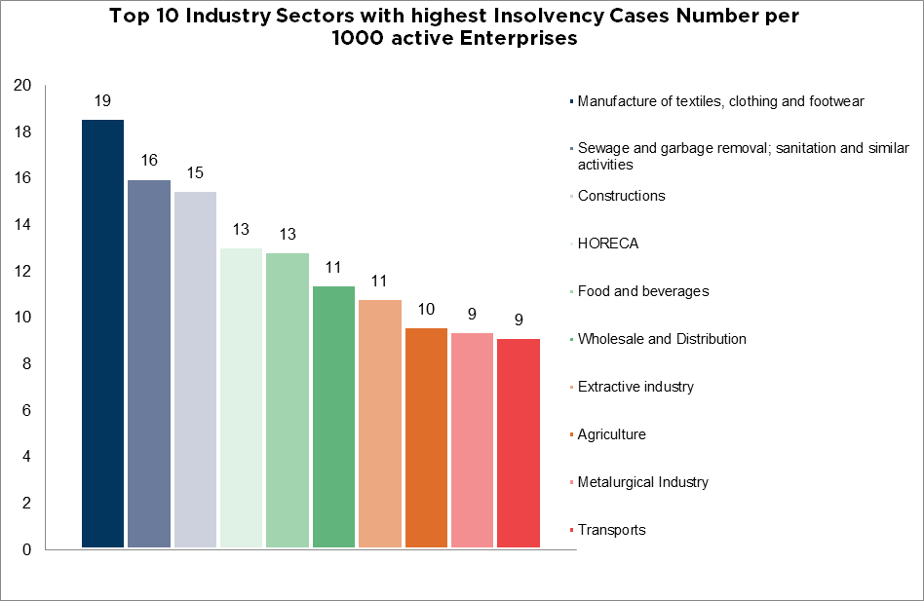

Source: BPI, MFP, Coface Data

